**Smart Temperature&Humidity Sensor**



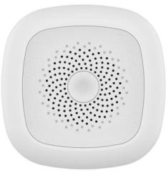

***Premium Add-on device for your home***

This Smart Temperature & Humidity Sensor adopts super low power consumption ZigBee wireless network technology, ensuring the stability of the product from the design. And it uses MCU microprocessor for intelligent temperature and humidity signals processing. Built-in high accurate temperature and humidity sensor, it can perceive and report real-time temperature and humidity data to APP. The product is suitable for environmental monitoring in residential, factory building, computer room , shopping mall, hotel, office building, teaching building, bank, library, as well as the warehouse and many other places.

***Features***

Specification

* Model Number: HS1HT-TY
* Working Voltage: DC3V
* Battery Type: CR2450 lithium battery
* Battery Life: 2 years
* Standby Current：≤6uA
* Alarm Current: ≤36mA
* Install Height：surface mounted
* Networking Way: ZigBee 2.4GHz
* Anti-RF Interference: 80MHz — 1GHz 10V/m
* Working Temperature: -10℃ ～ +60℃
* Working Humidity: ≤95%RH
* Product Size: 60x60x20.8mm
* Gross weight: 67g
* **Standard ZigBee protocol, good compatibility;**
* **Super low power consumption design, battery lifespan up to 2 years;**
* **Real time detecting temperature and humidity;**
* **Easy replacement of the battery;**
* **Low power alert and report function;**
* **Free tool installation, stick and play;**
* **Smart and fasion design, with appearance design patent;**
* **CE, ROHS, FCC approval**